**IMSE 982 Final Project**

**Blake Conrad**

* Python
* Numpy
* Pandas
* Conjugate Gradient Fletcher Reeves Method
* Golden Search
* Convex Convergence
* Multiple KKT point dispersion
* Penalty method feasibility

Problem 1: Quasi-convex function: Hyper-Bowl Function; $f:R^{3}→R$

$$f(x,y,z)=\left(x^{2}+y^{2}+x∙y\right)+\left(y^{2}+z^{2}+y∙z\right)+\left(x^{2}+z^{2}+x∙z\right)$$

$$∇f\left(x,y,z\right)=\begin{matrix}4x+y+z \\ 4y+x+z \\ 4z+x+y\end{matrix}$$

$$H\left(x,y,z\right)=\begin{matrix}4 & 1 & 1 \\ 1 & 4 & 1 \\ 1 & 1 & 4\end{matrix}$$

* Hessian is clearly Positive Definite, so our function is convex.
* We should expect given any random starting point we will converge to the same optimal solution via our algorithm of choice.

*Illustration 1:* Image to articulate a 4-dimensional surface with a single dimension (z) held constant (E.g., z=0).

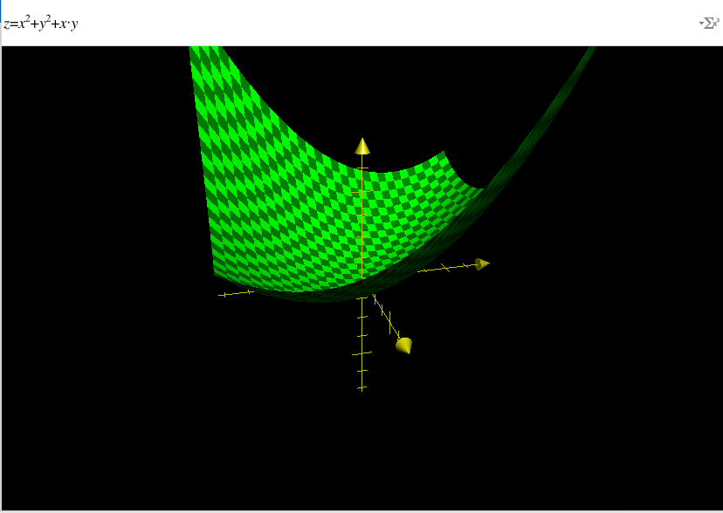

*Table 1:* 10 Samples of Conjugate Gradient Fletcher Reeves Method converging to the same point with different starting points.

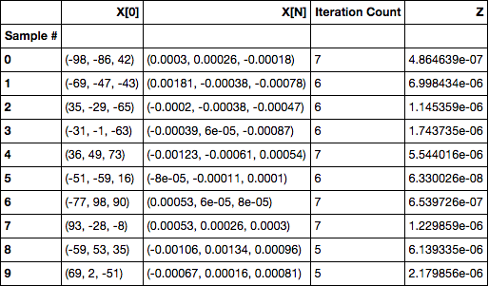

Illustration 2: Display of each sample converging to a point within a billionth of a decimal place to each other.

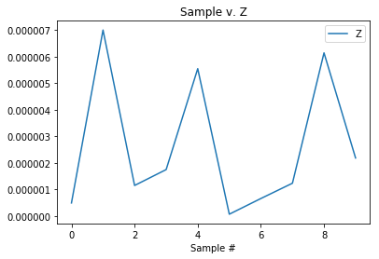

Problem 2: Non Convex Function (Multiple KKT Points): Periodic Wave Function; $f:R^{3}→R$

$$f\left(x,y,z\right)=\sin\left(x\right)∙\cos\left(y\right)+\frac{y}{z}+\frac{x}{z}$$

$$∇f\left(x,y,z\right)=\begin{matrix}\cos\left(x\right)∙\cos\left(y\right)+\frac{1}{z} \\ -sin\left(y\right)∙\sin\left(x\right)+\frac{1}{z} \\ -\frac{x}{z^{2}}-\frac{y}{z^{2}}\end{matrix}$$

$$H\left(x,y,z\right)=\begin{matrix}-sin(x)∙cos⁡(y) & -sin⁡(y)∙cos⁡(x) & -\frac{1}{z^{2}} \\ -cos⁡(x)∙sin⁡(y) & -\cos\left(y\right)∙sin⁡(x) & -\frac{1}{z^{2}} \\ -\frac{1}{z^{2}} & -\frac{1}{z^{2}} & \frac{2x}{z^{3}}+\frac{2y}{z^{3}}\end{matrix}$$

* Only convex when

  + ||

*Illustration 3:* Image to articulate a 4-dimensional surface with a single dimension (z) held constant (E.g., z=1).

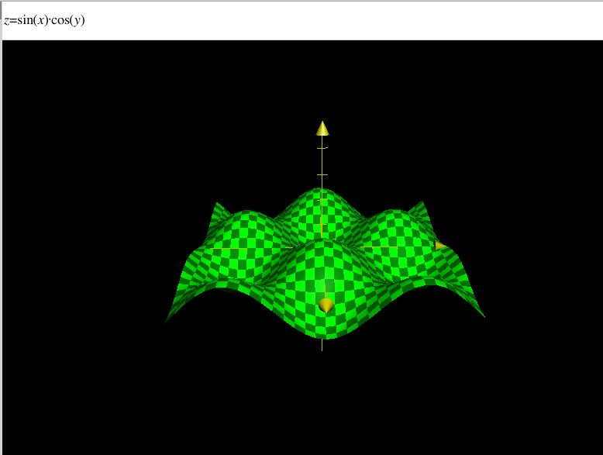

*Table 2*: Samples of Conjugate Gradient Fletcher Reeves Method converging to different points with different starting points.

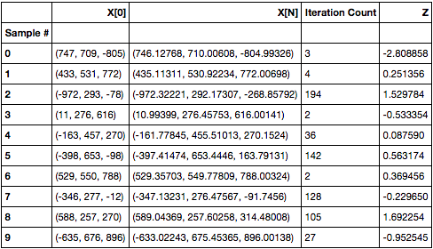

*Illustration 4:* Display of each sample distant from one another with varying final points.

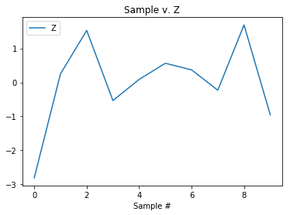

Problem 3: Constrained Quasi-convex function: Hyper-Bowl Function; $f:R^{3}→R$

$$f(x,y,z)=\left(x^{2}+y^{2}+x∙y\right)+\left(y^{2}+z^{2}+y∙z\right)+\left(x^{2}+z^{2}+x∙z\right)$$

subject to:

🡪 **-**

The Penalty Function will be defined as

$$f\left(x,y,z\right)=\left(x^{2}+y^{2}+x∙y\right)+\left(y^{2}+z^{2}+y∙z\right)+\left(x^{2}+z^{2}+x∙z\right)+ μ{[\left(x^{2}+y^{2}+z^{2}-1\right)+\left(-x-y-z+2\right)]}^{2}$$

* Paraboloid
* Inside of Hyper-sphere.
* Upper Half-space of Hyper-plane.
* We expect only 1 KKT point for a convex function as illustrated in problem 1.
* After running GRG, we expect our solution at $\overline{x}=\left(\frac{1}{2,},\frac{1}{2},\frac{1}{2}\right)and f\left(\overline{x}\right)=3$. Therefore, we expect under fletcher reeves conjugate gradient, $\lim_{μ→∞}{f\left(x,y,z\right)=3}$.